**Cane**

**Section 3**

SHOW SCHEDULE

**Herbert River Pastoral and Agricultural Association Inc**

**142nd**

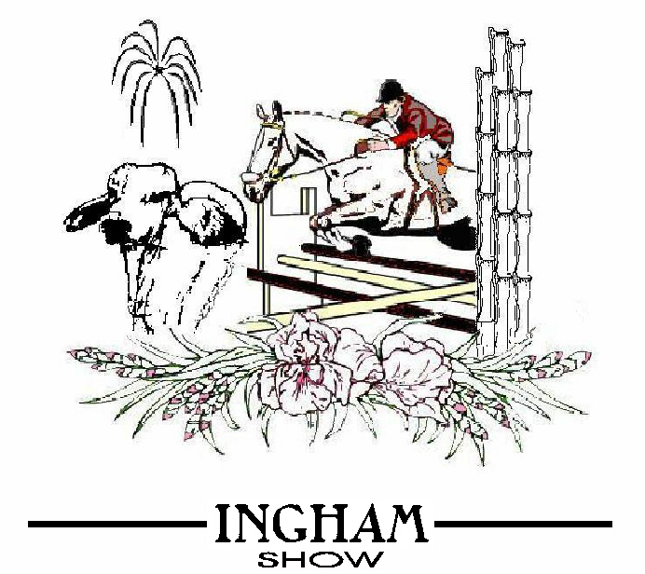

5

**26th & 27th June 2025**

**OFFICE BEARERS**

PATRON: Kevin Coper

PRESIDENT: W. Forden

VICE-PRESIDENTS: T Serra/D Hobbs

SECRETARY / TREASURER: S.Kelley

**COMMITTEE**

L. Amos, R. Balanzategui, K. Bowrey, J. Buckle, A. Buffa, Debbie Camp, K Cooper, C. Forden, W. Forden, T. Forden, L. Gimbert, B. Grant, D. Grant, J. Grant, D. Harragon, R. Harragon, D.Harragon, T.Harragon, D. Hobbs, R. Jackson, J. Jackson, J. Kelley, S. Kelley, B. Larsen, L. Marshall, G. Murray, L. O’Connor, A. Serra, L.A Stephensen, Jennifer Whalley, L Di Maggio, S Coco, S. Way, A. Way.

**HONORARY LIFE MEMBERS**

G.G. Allingham, G.O. Garbutt, E.C. Row, A.J. Andrews, O.W.D. Myatt, R. Larkin, D. Copley, A. Palmas,

G. Waring, G. Allara, J.M. Mizzi, A. Moretto, H. Benton, K. Phillips, D. Murray, E. Kehl, C. Kittle, K. Bowrey,

J. Renouf, R. Nazzari, P. Butler, A. Scott, F. Kelley, S. Serra, T. Christie, K. Cooper, L-A Stephensenr, L Molachino, I Hobbs, A Buffa, T Copley, L Marshall, A Serra, J Jackson, Jennifer Whalley, John Whalley.

**COMMITTEE RIBBONS**

**President:** Blue **Vice President:** Red

**Judge:** Purple **Steward:** Dark Blue

**Chief Steward:** White **Secretary:** Green

**PRIZE SASHES**

**Grand Champion:** White

**Champion:** Purple

**Reserve Champion:**  Green

**AWARD RIBBONS**

**First Place:** Blue

**Second Place:** Red

**Third Place:**  White

**SHOW ASSOCIATION OFFICE**

Showgrounds, Cooper Street, Ingham

PO Box 1009, Ingham Q. 4850

Telephone (07) 47765162

Email: [inghamshow@bigpond.com](mailto:inghamshow@bigpond.com)

**SECRETARY’S OFFICE HOURS**

THE SECRETARY’S OFFICE WILL BE OPEN AT THE

**INGHAM SHOW GROUNDS** AS OF

**MONDAY 9 JUNE – FRIDAY 13 JUNE**

**9.00AM – 4.30PM**

**MONDAY 16 JUNE – FRIDAY 20 JUNE**

**8.30 AM – 5.00PM**

**MONDAY 23 JUNE – WEDNESDAY 25 JUNE**

**8.00AM – 5.30PM**

**THURSDAY 26 JUNE 8.00AM – 12NOON ENTRIES ONLY**



**Herbert River Pastoral & Agricultural Association Inc**.

Proudly supported by the Queensland Government

A Message of Appreciation from the Herbert River Pastoral & Agricultural Association Committee

**WHAT A GREAT SHOW WE HAVE**

The Ingham Show Committee is run by a small group of people who believe in showcasing the Districts Skills and Talents over a 2 day event.

We are very well known for our Agricultural Show, with our Sugar Cane Display, Cattle Exhibits, Arts, Craft and Cooking just to name a few. It is a very special event for the locals and tourist that may be in town.

During the show we have many volunteers who dedicate their time in setting up whilst most people are still sleeping. From the many stewards working at their section of the show to those who work in the ticket office, Local Service Clubs working on the gates, stewards in centre ring moving jumps around till very late and cleaning up – they are a dedicated bunch.

To the Schools Students who dedicate time in helping set up and pack away some of the equipment for the show, we thank you, your support is very much appreciated.

So if you see a volunteer thank them as they are a rare breed, and our Show Society values all of our volunteers.

The Show Society would like to thank all the businesses in the district who have sponsored or donated over the past 138 Shows because without this support our Show can’t continue.

The community spirit for the show is very strong in our district. It has a brilliant atmosphere and we have found our entry levels are high. We are very proud to be involved with this Show Society and would like more people to come aboard with fresh ideas for another 142 Shows.

Have Fun at your Local Show.

Sharan Kelley, Secretary

0419 658 285

**SPONSORS -**

**MEMORIAL SPONSORS**

The Association wishes to record its sincere thanks to the following sponsors who have contributed towards the prize money and expenses of all Sections of our Show.

**MAJOR SPONSORS:**

**Wilmar Sugar**

**Hinchinbrook Shire Council**

**Herbert River Canegrowers Executive**

**Queensland Sugar Limited**

**McDonalds Family Restaurant**

**Rabo Bank**

**SECTION 1 Ring**

*W.O. Garbutt Memorial D Grade Jump*

*DS (Dave) Copley Memorial C Grade Jump*

*Jim Allingham Memorial C & D Grade*

*Herbert Valley Motel*

*Mrs ML Allingham Memorial Pair Hacks*

**SECTION 2 Cattle**

*Tropical Cattle Brahman Stud*

*Signature Brahmans*

*Palm Creek Brahmans*

*XMS Brahmans*

*Patrick & Sylvia Brown*

*AE Kehl*

*Mitre 10*

*M & L Naughton*

*Nutrien Ag Solutions*

*Fraser Family*

*DJ & KS Milton*

*R & D Hobbs*

*C & H Sheahan*

*Ingham Sugar City Rodeo*

*Elders Rural Townsville*

*Black River Cattle Equipment*

*Gallipos Midtown Meats*

*Ingham Carrying Service*

*Lanskeys Saddle World*

*Goughs Plastics Townsville*

*LA & PA Thomson*

*ST & VE Smith*

**SECTION 3 Cane**

*Wilmar Sugar*

*Queensland Sugar Limited*

*Herbert Cane Productivity Services Ltd*

*Sugar Research Australia*

*RaboBank*

*Nutrien Ag Solutions*

*NQIB Insurance*

*Ingham Agencies*

*Herbert River Canegrowers*

*Herbert River Trophy Centre*

*Don & Ivy Murray*

*M & L Mina Transport*

*Russo & Vella*

*Honeycombes*

*Ingham Travel*

*COSCA*

*QCAR*

**SECTION 5 Hall**

*Lou’s Food Emporium*

*Ingham Travel*

*A Palmas*

*Guido’s Paint & Panel*

*CWA Halifax*

*Merv’s Stationery*

*Jean Hulbert Memorial*

*Cyril Hulbert Memorial*

*Len & Ann Stephensen Memorial*

*Ingham Garden & Gifts*

*Fiori With Love*

*Herbert River Orchid & Allied Plant Society Inc*

*Ingham Floral Art*

*Wild Prawns*

**SECTION 16 School Display**

*Ando’s Mowing Service*

**SECTION 17 Poultry**

*Grant Family*

*Blanco’s Quality Meats*

*Jim Roberts Memorial – Donated by K. Bowrey*

**SECTION 18 Caged Birds**

*A Buffa, Ingham Avicultural Society*

*L & M Molachino*

**SHOW RULES AND REGULATIONS**

**Held under the Rules and Regulations of Queensland Chamber of Agricultural Societies**

**OPENING**

1. **The Show will be open to the public on Thursday 26th and Friday 27th June 2025 from 5.00pm. The various sections will be closed to the public during the period of judging stated in this Schedule and some sideshow attractions will be open from 4.00pm Thursday due to late arrival or other circumstances.**

**EXHIBITION**

1. On the Association's ground, or where the Executive may appoint. The Executive reserve the right at any time to postpone the Exhibition, or any event thereof, in consequence of the inclemency of the weather or for other sufficient cause to a date or dates deemed suitable by the Committee, and no entrance fee shall be returnable in the event of such postponement. The reasonableness of the cause or causes for postponement shall be decided by the Committee and their judgement shall be conclusive, and not open to question by an Exhibitor or other person affected by such postponement.
2. The Executive may abandon the Exhibition or any event thereof through wet weather, or for any other reason which may make such a course advisable in their opinion. Should the Exhibition or any event be abandoned or cancelled, Exhibitors shall be entitled to a return of the Entrance fee paid in such event or events as may be cancelled, but no cause or action, liability or obligation shall be maintainable against or be incurred by the Committee, or by the

Association by reason of such abandonment or cancellation.

1. Judging in all classes, unless otherwise stated, will commence on Thursday 26 June 2025.

**ADMISSION**

1. Members on presentation of their Tickets/Family Pass will be admitted free to the Grounds and Grandstands. Non members will be charged an admission fee of $20, children 6 to 16 years and pensioners $10. Vehicles will be charged an admission fee of $10. No Pass Out checks will be issued. Caravans will be charged $10 for the Show Period. Presold Pensioner admission tickets are available for $20 (admit both days) upon producing a current pensioner card.

**ENTRY FEES**

1. Non Members - such entry fee as shall be specified in the Schedule for each event.
2. Members - one half of each entry fee, to a maximum concession rebate of $5, except for Ring entries, where maximum rebate shall be to $10.

**PRIVILEGES OF MEMBERSHIP**

1. Payment of **$40** per annum grants admission to 2 Members and

Member’s children up to the age of 16 years accompanied by a

**Member** to grounds and grandstands on all days of the Show,

(vehicles admitted free), the right of entering exhibits at the above at reduced rates, and the right of nominating a fellow member for election to the Committee, or of being personally nominated for such position.

**GENERAL REGULATIONS**

1. All Cattle exhibits must be bonafide property of the Exhibitor from

the date of entry to the first day of the Show.

In the Horse section all exhibits must be bonafide property of exhibitor 60 days prior to Show and he or she shall make an

affidavit that such exhibit is his or her property.

Fruit, Flowers, Vegetables and Farm Produce must have been grown by the Exhibitor or the Prize Money will be withheld. This does not apply to Floral Art Section.

1. All entries must be made on printed forms from the Secretary on application, and as it is from these documents the catalogue will be compiled. It is absolutely necessary that the whole of the questions contained in them shall be answered as far as possible and sent to the Secretary by post or otherwise so as to reach the Office of the Society on or before the date when entries close. The entry fees in

all cases must be remitted with the entry forms, otherwise the entry will **not** be accepted. Entry fees will be acknowledged on official receipt forms.

1. Exhibits entered in the wrong classes by exhibitor may be transferred to the proper class by the Stewards on the direction of the judge or judges.
2. The Society may receive for exhibition only (not for competition) any exhibits not specified in this schedule provided there be sufficient space. The Society reserves the right to refuse any entry without giving reasons for doing so.
3. Exhibitors if called upon by Committee shall prove the correctness of their certificates of entry by statutory declaration or otherwise.
4. Responsibility for accuracy of pedigrees and of any other particulars required by prize schedule conditions rests solely with Exhibitors. Incorrect particulars or omission of particulars required may render competitor liable to forfeiture of prize money won, and to disqualification for such period as the Committee may deem fitting.
5. Entries in Livestock section will be taken as guarantee that the exhibit is free from disease. In case of infectious diseases being spread through a violation of this regulation, the Exhibitor must take the consequences. Should there be any reason to suspect that any exhibit is either dangerous or diseased, the Committee reserves the right of refusing admittance to or of removing the same from the ground at the expense of the Exhibitor.
6. The Society will not be responsible for an accident caused to, or through, or by an exhibit or person, and will not, under any circumstances, hold itself responsible for any loss or mis-delivery of livestock or other exhibit of any kind, or for any damage done thereto.
7. All exhibits must be delivered to and from the grounds at the risk of the Exhibitor.
8. All exhibits must be on grounds at time stated in Schedule, or if not stated, then not later than 8.30am on Judging Day .
9. The Judges will have the power to withhold any prize if they consider the exhibit of insufficient merit.
10. The Judges of any Section may recommend extra prizes for exhibits not specially provided for in the section, but it is distinctly understood that the recommendation is of no force unless ratified by the Committee.
11. In cases where there are other exhibits worthy of notice besides those to which prizes have been given, the Judges may award certificates of merit of such exhibits, viz. "Highly Commended".
12. **N**o entry will be received from any person disqualified by the Queensland Chamber of Agricultural Societies during the period of such disqualification. Should any such entry be accidentally accepted it shall, whenever discovered, be deemed void, and the entry fee will be forfeited.
13. No entries will be received except on the conditions that all disputes, objections and protests shall be decided by the Committee of the Society (or of any majority of those present) whose decision shall be final.
14. No protest will be considered unless lodged with the Secretary in writing before 6pm on the day of the competition, enclosing $5 which will be forfeited to the Society's funds should the protest be considered frivolous.
15. As soon as the Judges have made their awards in any class, the prize exhibit shall be distinguished by different coloured ribbons or cards: blue - 1st, red - 2nd, white - 3rd, white Special, purple - Champion, green Reserve - Champion.
16. The age classification of all animals competing in the Cattle Section will be determined by the tooth test. Stud animals entered in Herd Books will be accepted at actual age.
17. No exhibitor other than a Steward or Official Attendant of livestock exhibits will be allowed in that section of the ground or building in which the exhibits are placed during judging. Any person so offending shall forfeit the right to order the removal of such

offender from the grounds.

1. Exhibitors and persons admitted into the ground shall be subject to the regulations of the Stewards and any person or persons causing a nuisance by loud comments on the Judge's decision or other unseemly and insulting behaviour and not ceasing such nuisance after being cautioned, will be expelled from the grounds, and in the

case of exhibitors will be liable for disqualification.

1. Tickets for admission of attendants requiring to be present on the days of the Exhibition will be granted by the Secretary on application. Additional Attendants tickets may be obtained from the Secretary for $10 each. All Attendants will be subject to the control of the Stewards for the various sections. They will only be permitted to leave the grounds by the permission of the Stewards of the section to which they belong. Attendant’s tickets are not transferable and will pass the holder through the gates to 4pm Thursday and will be surrendered on Friday.
2. All exhibits must remain on the Showgrounds for the duration of the Show, but may be collected by Exhibitors on Saturday morning after the Show. No exhibit will be allowed to be removed without the sanction of the Secretary or the Stewards. In cases of a breach of this rule all prizes that may have been awarded to an exhibitor may be forfeited, unless satisfactory reason is given.
3. Prize money cheques unclaimed and outstanding for 6 months will be forfeited to the Society.
4. In case any dispute may arise as to the construction to be put upon any of the by-laws and regulations, the same shall be determined by the Committee of the Society, whose decision shall be final.
5. No Auctioneer will be allowed to sell on the Society's grounds unless he be a member.

Auctioneers shall pay to the Society, a commission of not less than 2% upon livestock sales effected on the Show grounds, whether by auction or by private contract.

**STEWARDS**

1. Stewards shall remove all other persons from the vicinity of the Judges while judging.
2. Stewards shall obtain Award Books from the Secretary and direct the Judge to the exhibit they are appointed to judge and shall carefully explain conditions of each class.
3. The Stewards shall attend to the Judges, to afford any information required but shall not do or say anything to influence their decision. They must not reveal the name of any exhibitor or repeat the remarks the Judges may make.
4. Stewards will obtain the Award Books from the Judges when filled up and signed and deliver same to the Secretary.
5. Stewards will obtain the prize cards or ribbons from the Secretary, and affix same to the exhibit after filling in names of successful exhibitor and other particulars.

**JUDGES**

1. Judges are expected to attend the Secretary's office on the Show grounds at the hour appointed and introduce themselves to the Secretary and to the Stewards of the Section.
2. Judges will receive Award Books from the Stewards of the section.
3. Judges, as they arrive at their decision will write their decision will write their award with any remarks they desire in the Award Books.
4. Judges shall disqualify any exhibitor who, in their opinion, does not comply with the regulations, and shall enter the reason in their books. Exhibitors to be notified accordingly.
5. Judges may recommend for Certificates or Commend as they think fit, any exhibits of special merit not included in the Schedule of Prizes, and need not award prizes in any class in which the exhibits are considered, in their opinion, of insufficient merit.
6. Judges will sign the Award Books and deliver them to the Stewards

**PROTESTS AND INQUIRIES**

1. In connection with all disqualifications, protests and inquiries, the Committee will cause full notes of evidence to be taken in writing. The person against whom any charge is made or whose conduct is being inquired into, must be afforded an opportunity of hearing the evidence taken at such inquiry and of cross-examining the witnesses and also of being heard and of producing evidence in his own defense. If such person fails to attend on such inquiry after due notice of the time and place of same, the Committee may proceed to hear such inquiry ex part or may adjourn the hearing of same as they may think fit.

**DISQUALIFIED COMPETITORS**

1. Owners, trainers, drivers, riders and horses disqualified by any Chamber of Agricultural Societies of the Commonwealth, or by any of the leading Racing Clubs, will not be allowed to compete.

**MISCELLANEOUS**

1. Where space has been let to any Exhibitor, the Committee reserves the right in case any such Exhibitor shall fail to make or maintain a creditable display, to declare the space allotted to him, or any portion thereof, forfeited, Exhibitors must arrange their exhibits in as attractive a manner as possible, and nearly fill up the space allotted to them, in default of which, the Committee may cancel their entries and require the removal of the goods. Once a position has been allotted to an Exhibitor, under no circumstances will such Exhibitor be allowed to remove his or her exhibit from its allotted position without first having obtained the permission of the Committee. This regulation applies to all positions disposed of.
2. The Committee reserves the right to prescribe the dimensions and regulate the positions of all signs and generally to direct the management of articles on exhibition so far as the same may be necessary to secure harmony and an attractive appearance. No person will be allowed to distribute about the grounds or buildings, handbills or advertisements that may cause a nuisance. Neat cards are recommended for this purpose as they are more likely to be kept by the visitors and not thrown on the ground.
3. No exhibitor or his attendant will be permitted to make unseemly noises that may be considered a nuisance in calling the attention of the visitors to his exhibits and any exhibitor or attendant who may be guilty of distributing any advertising cards or other notices that may be considered immoral, objectionable or in any way
4. If any person willfully injures or destroys any property within the grounds of the Association, or hinders or obstructs the Officers and Servants of the said Association or gains admission to the said grounds contrary to the rules of the Association, or the By-laws thereof, he will be prosecuted and dealt with as the law directs.

**NOTIFICATION OF SPACE**

1. Exhibitors are requested to intimate as early as possible to the Secretary, the extent of their exhibits in order that proper accommodation may be made for same.

**PAYMENT OF PRIZE MONEY**

1. The Committee reserves the right to withhold the payment of all Prize Money for at least 14 days following the completion of the Show.

**EXHIBITORS PASSES**

The Secretary may, at his/her discretion, issue 2 Exhibitors passes to holders of rented space only. Additional passes may be obtained on payment of $5 each, such passes to be valid until 4pm only on Friday. Passes are to be surrendered on Saturday.

**GOODS AND SERVICES TAX**

The HRP&A.A’s ABN is 22 283 390 180

**ENTRY FORMS**

* Exhibitors **must complete “STATEMENT BY EXHIBITOR”** section on the front page of the entry form advising their taxation status.

**PRIZE MONEY**

**\*** Prize Money stated in the Schedule **excludes GST**

* GST will be added to the Prize Money for Exhibitors who are **registered for GST purposes.**

**SECTION 3 CANE**

**IMPORTANT**

**Judging commences Thursday 26th June 2025 @ 8am.**

PLEASE NOTE: All entries should be cleaned of trash and unless an entry is for a stool class cane should also have the canopy tops removed to the nearest sound joint. In best stalks and collection classes please consider presentation by having cane with sound stalks, similar height, similar width and with a natural appearance (please do not polish). Cane in these classes are judged on the appearance of uniformity and varietal characteristics.

Special Regulations:

1. Only varieties currently approved for milling in the Herbert River Mills area are eligible, except historical classes.

2. Each exhibit must be labelled by the exhibitor, with the variety, the number of exhibit an exhibitor’s number on label provided prior to being handed to the Stewards.

3. All exhibits for TSH and "Sugarpol" must be delivered to the SRA/HCPSL office 181 Fairford Rd by 9am Tuesday 24th June.

All Exhibits except for TSH and "Sugarpol" must be delivered to the Showgrounds on **Wednesday 25th June** **11am – 5pm (Please note time change).**

4. Exhibits must be cut at ground level, except in the case of stools.

5. All stools to be cleaned of trash, dead stalks and suckers, but with the tops left on. In the heaviest sticks of cane classes tops shall be removed to the nearest joint of sound cane.

6. In any classes comprising stools of cane, the Judge shall satisfy himself that exhibit has been generated from one 'set' only, not more than 18 inches in length.

7. Any cane exhibited in 'Grown under Field Conditions', at the Show shall be grown by Cane Suppliers, their sons or daughters or Rural Youth of the Herbert River area.

8. All cane exhibited shall be limited to 18 months growth.

9. Judges attention is drawn to Regulation 44.

10. Cane exhibited under 'Any Condition' classes can be grown by any resident of the Herbert River District.

11. The Committee may require proof of Field Conditions stools' origin.

12. The committee reserves the right to form extra classes if required

**Stewards:**

L. Di Maggio - **0459 877 126.**

R. Harragon - **0400 558 766.**

S. Coco 4776 1808 – 0437 716 345.

G. Murray 4770 8180 – **0438 732 993.**

T. Serra 4777 2159 – **0427 772 159.**

D. Harragon 4776 0332 – **0417 753 662.**

**IMPORTANT**

**Judging commences Thursday 26th June at 8.00am**

**\*All exhibits for TSH and "Sugarpol" must be delivered to the SRA/HCPSL office 181 Fairford Rd by 9am Tuesday 24th June.**

**\*All Exhibits except for TSH and "Sugarpol" must be delivered to the Showgrounds on Wednesday 25th June 11am – 5pm (Please note time change).**

**ALL TROPHYS SPONSORED BY HERBERT RIVER TROPHY CENTER**

SCHOOLS COMPETITION

Entry Nil

**Grown under any conditions.**

**Open to all schools in the Herbert River District**.

**Class 301 WILMAR SUGAR**

**Best 6 stalks of any Historical Varieties**

**$50 1st**

$20 2nd

$10 3rd

**Class 302 WILMAR SUGAR**

**Best 6 Heavy Stalks of any Historical Varieties**

$50 1st

$20 2nd

$10 3rd

**Class 303 M & L MINA TRANSPORT**

**Best 6 stalks of any Approved Varieties to Plant (excluding those varieties released in the past 5 years - SRA10, WSRA24, SRA26, SRA28 and SRA36)**

$50 1st

$20 2nd

$10 3rd

**Class 304 INGHAM TRAVEL**

**Six Heavy Stalks of any Approved Varieties of any other Approved Varieties (released in the past 5 years - SRA10, WSRA24, SRA26, SRA28 and SRA36) to Plant**

**$50 1st**

$20 2nd

$10 3rd

**Class 305 M & L MINA TRANSPORT**

**Best TSH of Approved Varieties to Plant (please provide 7 stalks of the same variety)**

**$50 1st**

$20 2nd

$10 3rd

**Class 306 QUEENSLAND SUGAR LIMITED**

**Best Collection of 4 Approved Varieties to Plant (12 stalks in total with three stalks of each of the four varieties chosen bundled separately but bundled as a group to be presented)**

**$50 1st**

$20 2nd

$10 3rd

**Class 307 QCAR**

**Best Stool of any Variety**

**(Excluding Class 308)**

If sufficient entries, preference will be given to a section for new varieties released in the last 4 years or on stewards preference.

**$140 1s**t

$70 2nd

$40 3rd

**Class 308 HCPSL**

**Best Stool of Tissue Culture plant**

**(Supplied to school from HCPSL)**

**$50 1st**

$20 2nd

$10 3rd

**QUEENSLAND SUGAR LIMITED PERPETUAL** **TROPHY** -1st Prize - $250

AGGREGATTE OF POINTS 2nd - $125

AGGREGATE OF POINTS 3rd - $50

CHAMPION STOOL OF SCHOOL CANE EXHIBITS - $50

**Don & Ivy Murray Trophy $50 & Assn. Sash**

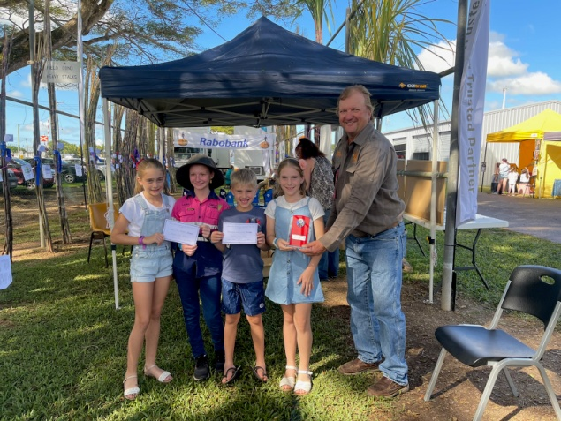

CHILDREN'S SECTION - Under 18

**EXHIBITOR FEE - $5 pp**

**(Note Change)**

Grown under any conditions.

Open to all children 18 years and younger in the Herbert River District

**Class 309 CANEGROWERS - HERBERT RIVER**

**Best collection of 4 any Approved Varieties to Plant (12 stalks in total with three stalks of each of the four varieties chosen bundled separately but bundled as a group to be presented) with Russo & Vella Trophy**

**$50 1st**

$25 2nd

$15 3rd

**Class 310 WILMAR SUGAR**

**Best Three Stalks of Q253**

**$50 1st**

$25 2nd

$15 3rd

**Class 311 CANEGROWERS - HERBERT RIVER**

**Best Three stalks of Q240**

**$50 1st**

$25 2nd

$15 3rd

**Class 312 INGHAM AGENCIES & CO**

**Best Three Stalks of Q208**

**$50 1st**

$25 2nd

$15 3rd

**Class 313 COSCA**

**Best Three Stalks of Any Historical Variety**

**$50 1st**

$25 2nd

$15 3rd

**Class 314 INGHAM AGENCIES & CO**

**Best Three Sticks of any other** **Approved** **Variety (excluded varieties are Q253, Q240 and Q208) to Plant**

**$50 1st**

$25 2nd

$15 3rd

**NUTRIEN AG SOLUTIONS TROPHY**

**CHAMPION 3 STALKS GROWN UNDER FIELD CONDITIONS**

$60 Prize Money and Assn Sash

**Class 315 NQIB INSURANCE**

**Best Six Heavy Stalks of Q208**

**$50 1st**

$25 2nd

$15 3rd

**Class 316 WILMAR SUGAR**

**Best Six Heavy Stalks of Q253**

**$50 1st**

$25 2nd

$15 3rd

**Class 317 CANEGROWERS - HERBERT RIVER**

**Best Six Heavy Stalks of WSRA24**

**$50 1st**

$25 2nd

$15 3rd

**Class 318 WILMAR SUGAR**

**Best Six Heavy Stalks of Q240**

**$50 1st**

$25 2nd

$15 3rd

**Class 319 WILMAR SUGAR**

**Best Six Heavy Stalks of any Historical Variety**

**$50 1st**

$25 2nd

$15 3rd

**Class 320 Russo & Vella**

**Best Six Heavy Stalks of any Approved Variety to Plant** (excluding Q208, Q253, WSRA24, Q240)

**$50 1st**

$25 2nd

$15 3rd

**Class 321 HCPSL**

**Best Six Stalks of any Approved Variety to plant**

**$50 1st**

$25 2nd

$15 3rd

**HCPSL TROPHY**

**AGGREGATE OF POINTS** –

**HCPSL Perpetual** 1st - $200

AGGREGATE OF POINTS - HCPSL 2nd - $100

AGREGATE OF POINTS - HCPSL 3rd - $60

**WILMAR SUGAR TROPHY**

**CHAMPION 6 HEAVY STALKS GROWN UNDER FIELD CONDITION**

$60 Prize Money and Assn Sash

**INGHAM AGENCIES & CO TROPHY**

**$60 1st**

$30 2nd

$15 3rd

GREATEST AGGREGATED WEIGHT OF 18 STALKS 1st

GREATEST AGGREGATED WEIGHT OF 18 STALKS 2nd

GREATEST AGGREGATED WEIGHT OF 18 STALKS 3rd

The greatest aggregate weight of 18 stalks, which is selected from the six heavy stalk classes of 3 different varieties grown under field conditions for the same exhibitor.

**Class 322 WILMAR SUGAR**

**Best Stool of any Historical Variety**

**$60 1st**

$30 2nd

$20 3rd

**Class 323 NQIB Insurance**

**Best Stool of any Approved variety to plant**

**$60 1st**

$30 2nd

$20 3rd

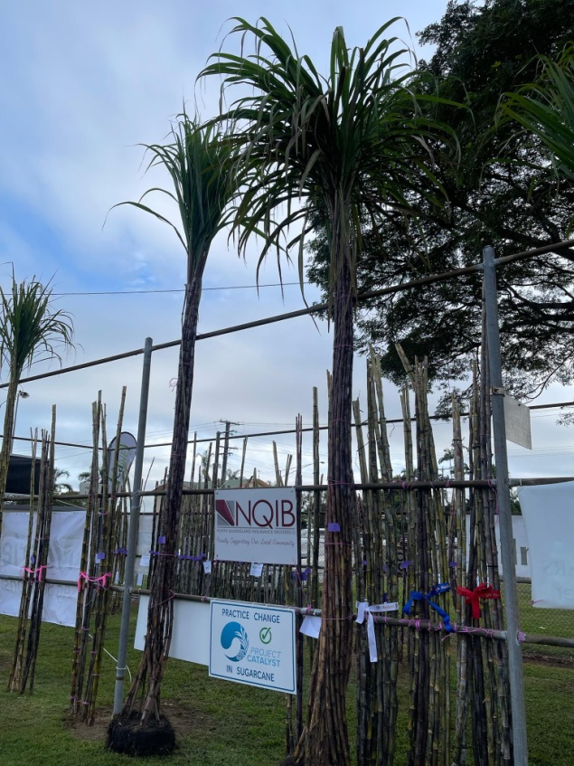

OPEN

**Entry per Class - $3**

**GROWN UNDER ANY CONDITIONS**

Open to all persons residing in the Herbert River District.

**Class 324 HONEYCOMBES**

**Best Stool of any Variety (Historical & Current)**

**$120 1st**

$60 2nd

$40 3rd

**Class 325 HONEYCOMBES**

**Best Six Heavy Stalks of any Historical Variety**

**$50 1st**

$25 2nd

$15 3rd

**Class 326 HONEYCOMBES**

**Best Six Heavy Stalks Open**

**$50 1st**

$25 2nd

$15 3rd

CHAMPION STOOL HISTORICAL CANE - $80

**(Combined OPEN's and U18's)**

HONEYCOMBES TROPHY

$80 Prize money and Assn. Sash.

GROWN UNDER FIELD CONDITIONS:

**Entry per Class - $3**

Exhibitors reminded of clause (11) in conditions

**Class 327 WILMAR SUGAR**

**Best Stool of Plant Cane of any approved variety (excluding Q208)**

**$70 1st**

$35 2nd

$20 3rd

**Class 328 WILMAR SUGAR**

**Best Stool of Plant Cane Q208**

**$70 1st**

$35 2nd

$20 3rd

**WILMAR SUGAR TROPHY**

CHAMPION STOOL PLANT CANE APPROVED

$80 prize Money and Assn Sash

**Class 329 WILMAR SUGAR**

**Best Stool of Ratoon Cane of any approved variety (excluding Q208)**

**$70 1st**

$35 2nd

$20 3rd

**Class 330 WILMAR SUGAR**

**Best Stool of Ratoon Cane of Q208**

**$70 1st**

$35 2nd

$20 3rd

**WILMAR SUGAR TROPHY**

CHAMPION STOOL RATOON CANE

$80 prize Money and Assn Sash

**SHAUN SHEAHAN MEMORIAL**

GRAND CHAMPION STOOL –

Under Field Conditions

$100 Prize Money and Assn Sash. (Sponsored by **WILMAR SUGAR**)

**BEST COLLECTION OF 10 STALKS**

**$50 1st**

$20 2nd

$10 3rd

**Class 331 NUTRIEN AG SOLUTIONS**

**Best Collection of 10 Stalks of Q253**

**Class 332 NUTRIEN AG SOLUTIONS**

**Best Collection of 10 Stalks of Q208**

**Class 333 NUTRIEN AG SOLUTIONS**

**Best Collection of 10 Stalks Q240**

**Class 334 NUTRIEN AG SOLUTIONS**

**Best Collection of 10 Stalks of SRA14 or Q200 (the variety must be identified)**

**Class 335 NUTRIEN AG SOLUTIONS**

**Best Collection of 10 Stalks of any other Approved Variety**

To be judged on appearance uniformity and variety characteristics and each exhibit shall consist of 10 stalks without tops

**NUTRIEN AG SOLUTIONS TROPHY** $80 Prize money & Assn. Sash

CHAMPION 10 STALKS GROWN UNDER FIELD CONDITIONS

**BEST 6 HEAVIEST STALKS**

**$50 1st**

$20 2nd

$10 3rd

**Class 336 RABO BANK**

**Best 6 Heaviest Stalks of Q240**

**Class 337 RABO BANK**

**Best 6 Heaviest Stalks of Q208**

**Class 338 RABO BANK**

**Best 6 Heaviest Stalks Q253**

**Class 339 RABO BANK**

**Best 6 Heaviest Stalks of any other Approved Variety**

**RABO BANK TROPHY**

$80 prize money and Assn Sash

CHAMPION 6 HEAVY STALKS

GROWN UNDER FIELD CONDITIONS:

**INGHAM AGENCIES & CO**

**TROPHY** and

**$80 1st**

$40 2nd

$20 3rd

GREATEST AGGREGATED WEIGHT OF 18 STALKS 1st

GREATEST AGGREGATED WEIGHT OF 18 STALKS 2nd

GREATEST AGGREGATED WEIGHT OF 18 STALKS 3rd

The greatest aggregate weight of 18 stalks, which is selected from the six heavy stalk classes of 3 different varieties grown under field conditions for the same exhibitor.

**COLLECTION OF MILLING CANE**

**Class 340 CANEGROWERS - HERBERT RIVER**

**The best collection of cane being 5 Stalks of any 4 Approved Varieties.**

To be judged on appearance, uniformity of growth and variety characteristics. Tops to be removed and varieties to be listed on exhibit.

**Canegrowers - Herbert River Trophy**

**$50 1st**

$20 2nd

$10 3rd

**C.C.S. COMPETITION**

**Class 341 Sugar Research Australia - HERBERT**

**"Sugarpol" - 7 Stalks of any approved variety.**

Competitors in this section must enter 7 stalks of cane properly topped. Stalks to be weighed and analysed, the product of the two results to determine the placing (Tonnes of Sugar for seven stalks).

All exhibits for TSH and "Sugarpol" must be delivered to the SRA/HCPSLoffice 181 Fairford Rd by Tuesday 24th June at 9:00am .

Exhibits to be firmly tied and securely labelled with class, entry number and variety.

**"SUGARPOL" TROPHY** and

**$50 1st**

$20 2nd

$10 3rd

**HERBERT CANE STEWARDS TROPHY**

MOST ENTRIES GROWN UNDER FIELD CONDITIONS - $80

**HERBERT RIVER DIGGERS MEMORIAL TROPHY**

Dedicated in perpetuity to the Herbert River Pastoral and Agricultural Association by the Herbert River Sub-Branch RSL to the memory of all those men who enlisted for Active Service from the Herbert River District. This trophy is to be won by the exhibitor gaining greatest aggregate of points in the section arrived at by allotting 2 points for first, 1 point for second.

**HERBERT RIVER DIGGERS MEMORIAL TROPHY**

GREATEST AGGREGATED POINTS IN FIELD STALKS CLASSES

$150 Prize Money & Assn Sash

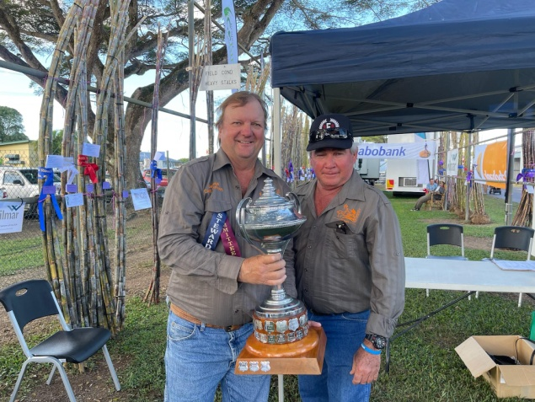

**THANK YOU**

The Committee expresses its sincere gratitude to all donors listed throughout this Schedule who have generously given valuable support for many years. We trust that the community will support these donors in appreciation of their continued support of our Local Show.

**ENTERTAINMENT**

**INGHAM SHOW 2025**

* **Fire Works – Friday Night**
* **Carters Petting Farm**
* **NQ Tractor Pull – Friday**
* **Six Bar competition – Friday**
* **Sausage Dog Derby – Friday**
* **Doggy High Jump – Friday**
* **Outback Jack’s Stockman Show – Friday centre Ring**
* **2025 Show Dates**
* **June:**
* Bowen   24 June
* Ayr   25 June
* Ingham (Herbert River) 26 – 27 June
* Malanda   27 – 29 June
* Atherton 30 June – 1 July
* **July:**
* Innisfail   10 - 11 July
* Mareeba 12 - 13 July
* Cairns  16 - 18 July
* Mossman 20 - 21 July
* Tully 25 - 26 July
* Charters Towers 27 - 29 July