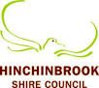

8:00am Centre Ring – Showjumping

8:30am Judging - Poultry Pavilion

Judging - Canine (Dog Show)

Judging - Stud Cattle

9:00am Gates Open to Public

Centre Ring – Hacking Rings

12:00noon Open - Refreshment Booths

10:30am Centre Ring – Sausage Dog Fancy Dress – Judged by our Showgirl Entrant

11:00am Judging - Cattle – Led Steer/Heifer

Judging - Junior Parader’s (Cattle Pavilion)

Centre Ring – Sausage Dog Derby

Entertainment – Memphis Moovers

11:00am Main Arena - Woodchop

Trophy Presentation – Cattle pavilion

1:00pm Centre Ring – Horse Sports

3:00pm Entertainment – Racing Pigs/Ducks

3:00pm Centre Ring – 2nd Sausage Dog Derby

3:30pm Entertainment – Memphis Moovers

5:00pm Entertainment – Racing Pigs/Ducks

Entertainment – Memphis Moovers

7:00pm Entertainment – Racing Pigs

7:30pm Centre Ring –Introduction of 2023 Miss Showgirl Entrant

8:00pm Main Arena – Airtime FMX Motorcycles

8:00pm Opposite Show Office -Army Jazz Band

8:30pm Main Arena – Fireworks

Poultry Pavilion – Closing

Caged Bird Pavilion – Closing

10:30pm Exhibition Hall – Closing

12:00am Refreshment Booths - Closing

8.30am Centre Ring – Showjumping Ring

8:30am Judging – Exhibition Hall

9.00am Centre Ring – Hacking Rings Commence

9:30am Judging - Poultry

5:00pm Open - Gates Open to Public

* Side Show Alley
* Exhibition Hall
* Caged Bird Pavilion
* Poultry Pavillion
* Refreshment Booth (Pavilion)
* Refreshment Booth (Grandstand)

5:00pm Centre Ring – Six Bar Competitions

5:30pm Roving - Memphis Moovers

6:00pm(Approx) Centre Ring – Dog High Jump

6:00pm Entertainment – Racing Pigs/Ducks

6:30pm Trophy Presentation – Cane Exhibits

8:00pm Entertainment – Racing Pigs/Ducks

9:00pm Caged Birds & Poultry Pavillion Closing

10:30pm Closed - Exhibition Hall

12:00am Closed - Refreshment Booths

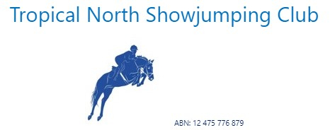

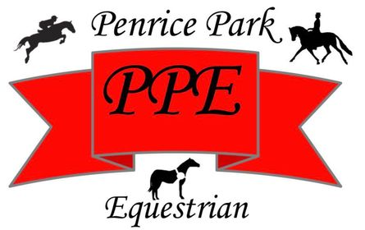

**negrowers**

**Canegrowers**

Herbert River

**Thursday 6th July 2023** **Friday 7th July 2023**





**Canegrowers**

Herbert River









